**Lab Steps**

**Task 1: Sign in to AWS Management Console**

1. Click on the **Open Console** button, and you will get redirected to AWS Console in a new browser tab.
2. On the AWS sign-in page,
   * Leave the Account ID as default. Never edit/remove the 12 digit Account ID present in the AWS Console. otherwise, you cannot proceed with the lab.
   * Now copy your **User Name** and **Password** in the Lab Console to the **IAM Username and Password** in AWS Console and click on the **Sign in** button.
3. Once Signed In to the AWS Management Console, Make the default AWS Region as **US East (N. Virginia) us-east-1.**

**Task 2: Launching EC2 Instance**

In this task, we are going to create an EC2 Instance by providing the required configurations like name, key pair, instance type, security groups and role access the AWS S3 service.

1. Make sure you are in the**US East (N. Virginia) us-east-1**Region.
2. Navigate to **Services** menu in the top, then click on **EC2** in the **Compute** section.
3. Click on **Instances** from the left side bar and then click on **Launch instances**button.
4. Name : Enter **S3EC2server**

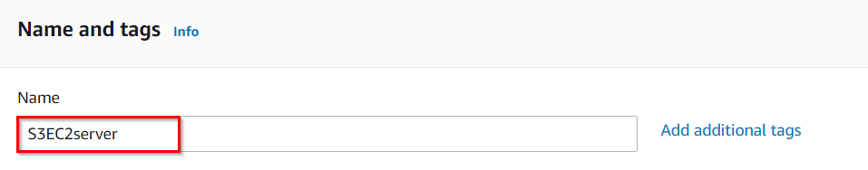

      5. **For Amazon Machine Image (AMI):** Search for **Amazon Linux 2 AMI** in the search box and click on the **select** button.

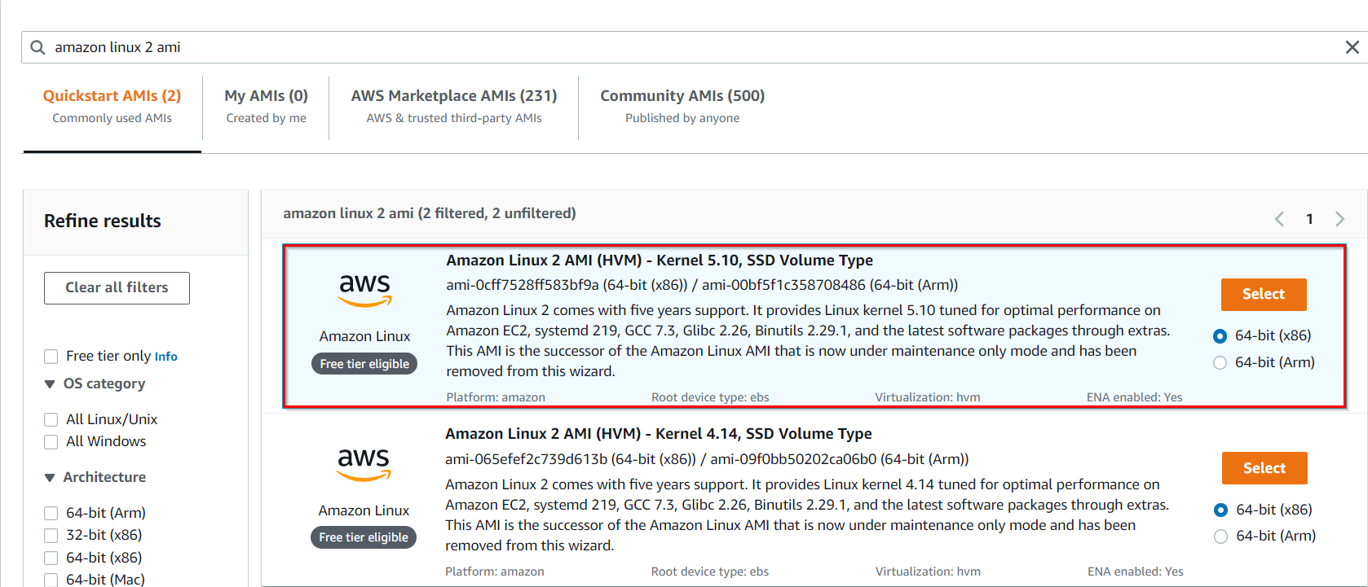

**Note: if there are two AMI's present for Amazon Linux 2 AMI, choose any of them.**

1. **For Instance Type:** select ***t2.micro***

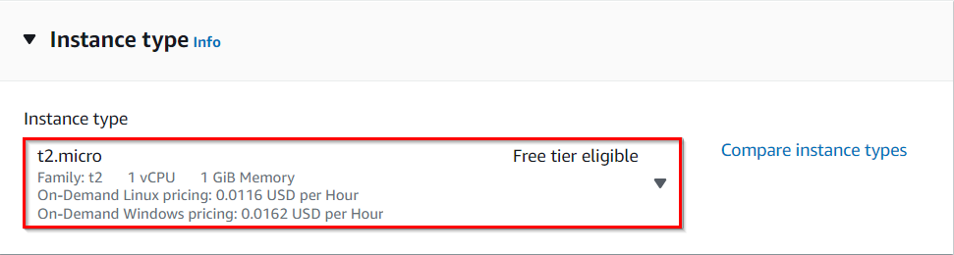

1. **For Key pair:** Select **Create a new key pair** Button
   1. Key pair name: **WhizKey**
   2. Key pair type: **RSA**
   3. Private key file format: **.pem**
2. Select **Create key pair** Button.

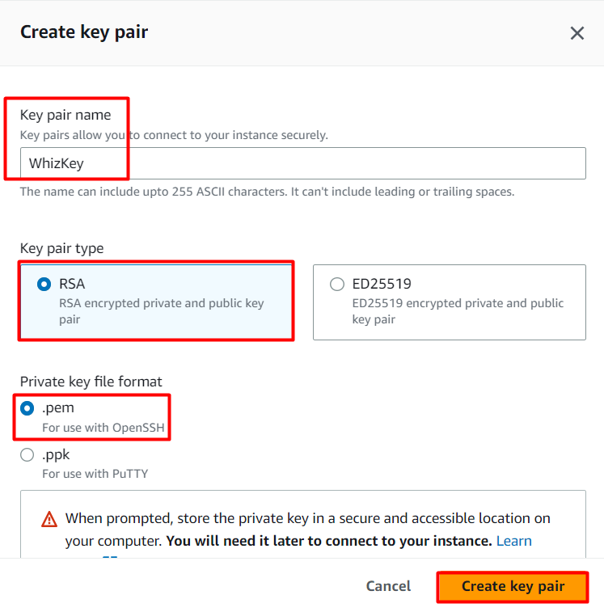

       9. In Network Settings Click on **Edit**button:

* Auto-assign public IP: **Enable**
* Select **Create new Security group**
* Security group name : Enter ***S3server-SG***
* Description : Enter ***Security Group to allow traffic to EC2***
* To add **SSH**
  1. **Choose Type:**Select **SSH**
  2. **Source**: Select **Anywhere**

1. Click on **Advanced details.**
2. In IAM instance Profile : Select **task_46_profile<RANDOM_NUMBER>** which is already created for you.
3. Keep Rest thing Default and Click on **Launch Instance** Button.
4. Select **View all Instances** to View Instance you Created
5. **Launch Status:** Your instances are now launching, Navigate to **Instances** page from left menu and wait the status of the EC2 Instance changes to running.
6. You can tell that the instance is running by checking the instance status (example below).



    16. **Select** the instance and **copy** the Public IPv4 address and save it in any text editor.

**Task 3: Viewing the S3 Bucket**

In this task, we are going to verify the bucket already pre-created for you.

1. Navigate to the **Services** menu at the top. Click on **S3** in the **Storage** section.
2. You can see a bucket with a name similar to ***whizlabs7577123847772***.

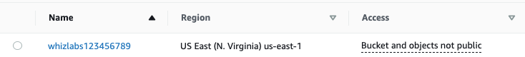

**Task 4: Accessing the S3 bucket via EC2 Instance**

In this task, we are going to access the S3 bucket via the EC2 instance and will upload the files to S3 via EC2 shell.

1. To SSH into the server, please follow the steps in [SSH into EC2 Instance](https://www.whizlabs.com/labs/support-document/ssh-into-ec-instance).
2. Once logged in, switch to the root user:

sudo su

1. Run the below command to find your S3 bucket via CLI.

aws s3 ls

1. You will see output similar to the image below, which shows that we are able to access the S3 bucket with the help of role attached to the EC2 instance.

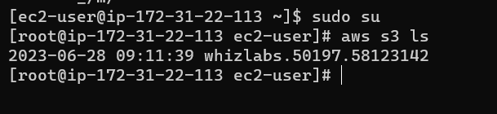

1. Create a new text file and upload it to the bucket via AWS CLI (using the following set of commands):

touch test.txt

aws s3 mv test.txt s3://<your_bucket_name>

* + **Note : You need to enter your bucket name.**

1. Check for the new file in the S3 bucket.

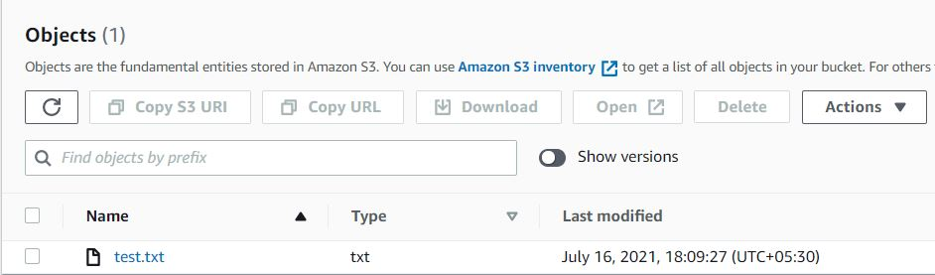

1. Repeat step 5 and create some more files like **new.txt, smile.txt** and upload it to the S3 bucket using below commands:

touch new.txt smile.txt

aws s3 mv new.txt s3://<your_bucket_name>

aws s3 mv smile.txt s3://<your_bucket_name>

* **Note : You need to enter your bucket name.**

     8. You can confirm the files uploaded to S3 bucket by navigating to the bucket in the AWS console.

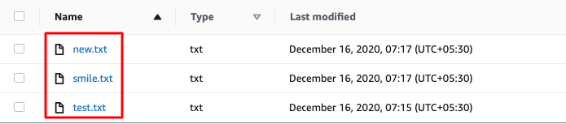

1. You can also list the files uploaded to S3 bucket via CLI from the EC2 instance with the following command:

aws s3 ls s3://<your_bucket_name>

* + **Note : You need to enter your bucket name.**